E-Giants Technology

Funtional Requirements Document
Tax Benefit Application
Version 0.1

Document Revisions
Date | Version Number | Document Changes
06/17/2019 | 0.1 | Initial Draft

Approvals
Role | Name | Signature | Date
Project Sponsor | Krishna
Business Analyst | Hemisha Goti
Database administrator | Ashok
User Experience Lead | Sudha
Security Lead | Neha
Test Lead | Teja

Table of Content

- General
  - Project overview 4
  - Project Scope 4
  - Assumption and constraints 4
  - Point of Contact 5
- Functional requirements 6
  - Data requirement (ERD diagram) 10
  - Prototypes 10
- Security 13
  - Recoverability 14
  - System availability 14
  - Performance 14
  - Capacity 14
  - Data retention 14
- Requirement Traceability Matrix 14

General

Project Description
The Tax Benefit application will give people an online tax filing platform. The mission of the project is to provide the end users an easy and a fast way to file taxes and get tax refund. The application considers different type of users and based on it services are given based on their information and needs
The three main services provided by the Tax benefit are:
- Individual filing
- Business filing
- Organization filing
Additional features of the application will be as follows:
- A Tax calculator will be developed, so that the user can estimate how much tax they will pay based on their income
- A Tax return feature will be built in order to allow users to estimate how much return they can get.
- A Tax expert team will be providing to guide the user with their tax filing.
- A tax summary will be provided, so that users can check your tax filing history

1.2 Project Scope

In Scope
- Users will be able to search their tax file in the website through tax id
- An automated tax id will be generating for each individual user
- The system will provide a tracking system, once their tax file is submitted
- Users from all the states can use the application

Out of Scope
- This application is limited to United states
- Changes to existing Database schema

Assumptions and Constraints
Assumptions are future situations, beyond the control of the project, whose outcomes influence the success of a project. The following are examples of assumptions:

- All the resources needed for the project is available.
- The user of the application will have all the documents from the checklist mentioned.
- The tax filing status will take minimum 30 days after the user has completed the filing process.
- The Government taxation agency (Third party) will provide us the documents checklist for all the three services provided by Tax benefit application.
- The tax expert team will be able to solve maximum queries of the users at business working hours
- The user will provide the previous tax filing details, so that tax benefit application can keep record of it and display them in Summary filing

Constraints

- The project should be completed in 2 weeks
- The Budget is restricted to initial investment
- The Tax benefit application has to work on Business standard BS-1900
- The User has to meet the government taxation agency standards:
- IRS 1040
- TRF 345

Points of Contact
List the names, titles, and roles of the major participants in the project. At a minimum, list the following:

Stakeholder ID | Name of the stakeholder | Role
1 | Krishna | Product Owner
2 | Hemisha | Business Analyst
3 | Neha | Security Analyst
4 | Ashok | Database administrator
5 | Sudha | UI developer

FUNCTIONAL REQUIREMENTS

Req id | User Story | Acceptance criteria
1 | As a project owner, I want to allow Individuals to file their tax return with Tax benefit, so that they don’t have to depend on CPA and give them an online platform for filing their taxes | For filing tax return with Tax benefit, it is mandatory to have an account with Tax Benefit.
2 | As a project owner, I want to allow Businesses to file their tax return with Tax benefit, so that they don’t have to depend on CPA and give them an online platform for filing their taxes | For filing tax return with Tax benefit, it is mandatory to have an account with Tax Benefit.
3 | As a project owner, I want to allow Organization to file their tax return with Tax benefit for their employees, so that they don’t have to depend on CPA and give them an online platform for filing their taxes | For filing tax return with Tax benefit, it is mandatory to have an account with Tax Benefit.
4 | As a project owner, I want a logo on the home page, so that I can create a recognition of my website. | 1 The logo should be patent  2. The logo should have a copyright  3. The size of the logo should be in such a way that it brings the attention of the customers
5 | As a user of Tax benefit, I want to create an account, so that I can file my returns. | - For create account the fields required are:  -Email address  - User ID  -Password  -Mobile No (Recommended)  - User should agree with the terms and conditions of Tax benefit website for filing the tax returns and creating account.  - requirements for User id  - User id should have one upper case letter  - Max letters 15  - Min 3  - User id can be your email id  - Requirements for password:  - Password should have at least 15 characters OR at least 8 characters including a number, a lowercase letter and uppercase letter.  5. There should be field that confirms the user password, that they entered
6 | As a Government taxation agency, I want the system to generate a tax payer id for users, so that all the records can be retrieved through the id | - The Tax payer id must be of 8 digits  - The tax payer id can have 2 letters in it
7 | As an old user, I want to login into my account, so that I can start working on my tax filing. | 1 User should have a User id and password to login
8 | As a user, If I forget my password I want the website to send me a link in my email, so that I can recover my password | Steps involved:  - User will click Forgot password  - The website will ask the user for email address.  - A link should be sent to user, which redirects them to a new page  - The page will ask the user the security questions that they choose while creating the account. (at least 3)  - The page will ask the user to enter new password  - The page will ask user to confirm the password entered.  Criteria  - The new password cannot be same as the old password  - Password should have at least 15 characters OR at least 8 characters including a number, a lowercase letter and uppercase letter

9 | As a Government taxation agency, I want user information for Individual filing, so that I can complete their tax filing | The information required from the user are as follows:  1 First Name  2 Last Name  3 Date of Birth  4 Email  5 Marital status  - Single  - Married  - Widow  6 SSN  7 Organizations Name  8 Office Address  9 Home Address (Permanent)  10 Mailing Address  11 Phone Number  12 Employment Status
10 | As a Government taxation agency, I want Organization’s information for Organization filing, so that I can complete their tax filing | The information required from the Organization are as follows:  1 Name of the Organization  2 No of employees in the organization  3 Type of organization  - Corporate  - Industrial  - Non- Profit organization  4 Organization’s address  5 Organization ID  6 Email address of the organization  7 Organization phone number  8 The name of the person filing for the organizations  - First Name  - Last Name  - Email  - Phone no  9 The No of employees you are filing tax return?  10 All the details of the employees ( Include all the fields from Req id 8)
11 | As a Government taxation agency, I want Business information for Business filing, so that I can complete their tax filing | The information required from the Business are as follows:  1 Name of the Business  2 Type of Business  3 Business Email  4 Business Phone number  5 Name of the CEO  - First Name  - Last name  - Phone no  - Email  6 Business address  7 No of people working in the business  8 Business License No
12 | As a user of tax benefit application, I want a documents checklist, so that I can know what documents need to be uploaded for filing taxes | The documents checklist:  Individual  - Id proof  - W-2  - SNN  - IRS 1030 form  Organization  - Organization certificate  - D-4  - TRN 1200 form  - Organization license  Business  - CEO id proof  - Business Licensee  - BT 3200  - Business Balance sheet

Data Requirements (ERD Diagram)
Describe the data requirements by producing a logical data model, which consists of entity relationship diagrams, entity definitions, and attribute definitions. This is called the application data model. The data requirements describe the business data needed by the application system. Data requirements do not describe the physical database.

Prototypes
Landing page

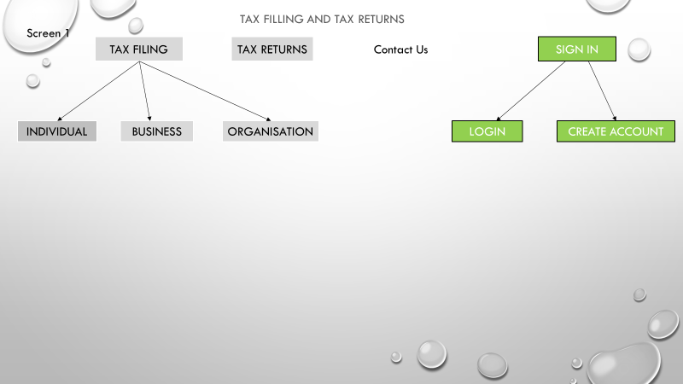

Login Screen

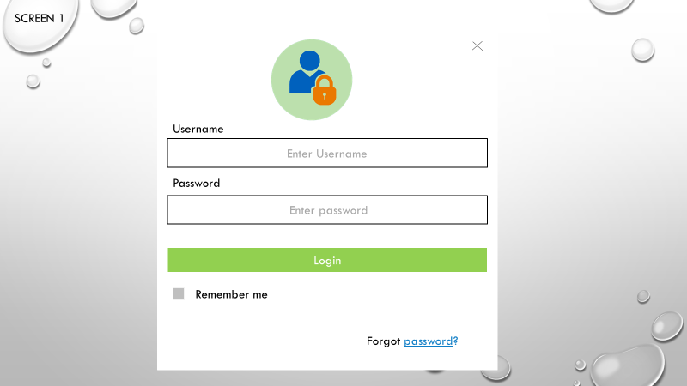

Create Account page

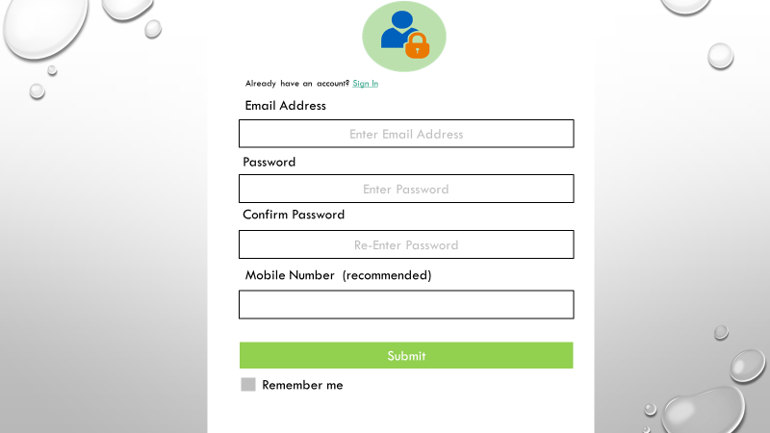

User Profile
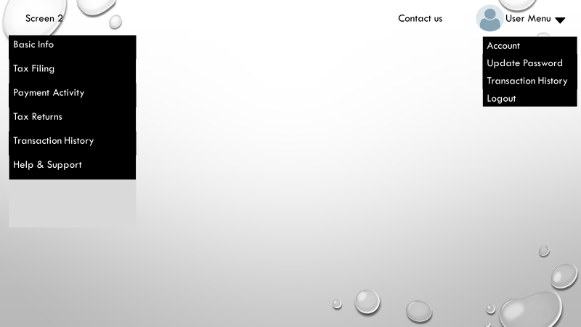

Individual filing page

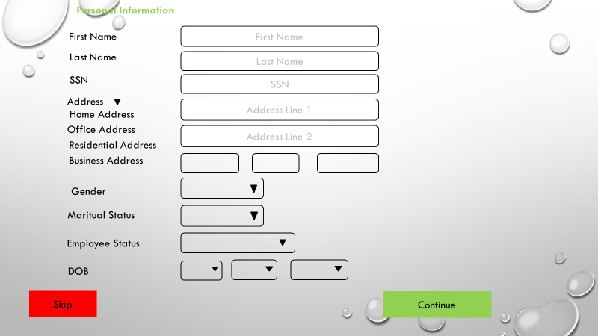

Security
The security Section describes the need to control access to the data. This includes controlling who may view and alter application data.

State the consequences of the following breaches of security in the subject application:

- Erasure of contamination of application data
- Disclosure of Government secrets
- Disclosure of privileged information about individuals

State the type(s) of security required. Include the need for the following as appropriate:

State if there is a need to control access to the facility housing the application.

- State the need to control access by class of users. For example, “No user may access any part of this application who does not have at least a (specified) clearance.”
- State the need to control access by data attribute. State, for example, if one group of users may view an attribute but may not update it while another type of user may update or view it.
- State the need to control access based on system function. State for example, if there is a need to grant one type of user access to certain system functions but not to others. For example, “This function is available only to the system administrator.”
- State if there is a need for accreditation of the security measures adopted for this application. For example, C2 protection must be certified by an independent authorized organization.
Answer that question for each type of data request.

Recoverability
Recoverability is the ability to restore function and data in the event of a failure. Answer the following questions in this section:
- In the event the application is unavailable to users (down) because of a system failure, how soon after the failure is detected must function be restored?
- In the event the database is corrupted, to what level of currency must it be restored? For example “The database must be capable of being restored to its condition on no more than one hour before the corruption occurred.”
- If the process site (hardware, data, and onsite backup) is destroyed how soon must the application be able to be restored?

System Availability
- The Application must be available at all times to its users. All messages sent or received via the application must eventually be stored in the associated database.
- The application should be executable / accessible from at least the following web browsers:
- Internet explorer
- Mozilla Firefox
- Google Chrome
- Safari
- Application should be accessible via mobile devices such as Ipads, Laptops and smart phones.

Performance
- The maintenance of the system will be conducted on weekends during night time
- The users should be able to view their uploaded documents and their tax filing status in 30 sec
- If there is any server issues the user will be able to see the query in 2 seconds
- The backup of all the data should be done regular

Capacity
- The application should be able to handle 100,000 users per month
- The maximum number of users that application handle per month is 160,000

Data Retention
- Information about an application for naturalization must be retained in immediately accessible from for three years after receipt of the application.

REQUIREMENTS TRAcE ABILITY MATRIX
The requirements trace ability matrix (RTM) provides a method for tracking the functional requirements and their implementation through the development process. Each requirement is included in the matrix along with its associated section number. As the project progresses, the RIM is updated to reflect each requirement’s status. When the product is ready for system testing, the matrix lists each requirement, what product component addresses it, and what test verify that it is correctly implemented.

Include columns for each of the following in the RTM:

- Requirement description
- Requirement reference in FRD
- Verification Method
- Requirement reference in Test Plan

